FARM MANAGEMENT SYSTEM

User Story
As a farmer, farm manager, or system administrator, I want to use a centralized Salesforce-based platform to manage farmer, farm, crop, and buyer information securely. The system should support easy data entry, validation, reports, dashboards, and role-based access so that agricultural operations can be managed efficiently with fewer errors and less paperwork.
1. Introduction
1.1 Project Overview
The Farm Management System (FMS) is a Salesforce-based application that digitizes agricultural operations. It manages farmers, farms, crops, and buyers and provides reports and dashboards for real-time analysis.
1.2 Purpose
- Digitize agricultural records
- Improve data accuracy and accessibility
- Reduce manual work
- Enable real-time monitoring
- Support better farm decisions
2. Ideation Phase
2.1 Problem Statement
User | Problem | Expected Benefit
Farmer | Manual and incomplete records | Accurate digital records
Farm Manager | Delayed productivity and sales reports | Real-time monitoring
Buyer | Crop information is not updated regularly | Centralized information
Admin | Manual access control | Secure role-based access
2.2 Empathy & Brainstorming
Users need accurate and timely data. Existing methods include registers, paper files, and spreadsheets.
Ideas considered: manual records, Excel management, web/mobile applications, and Salesforce-based FMS.
Selected Idea: Salesforce-based Farm Management System.
3. Requirement Analysis
3.1 Customer Journey
Login → Open FMS → Enter Data → Manage Farmers/Crops/Buyers → Generate Reports → View Dashboard → Decision Making
3.2 Functional Requirements
- User Authentication
- Farm, Crop, Farmer and Buyer Management
- Data Validation
- Object Relationships
- Reports
- Dashboards
- Role Management
3.3 Non-Functional Requirements
- Usability – simple Salesforce Lightning interface
- Security – profiles, roles and sharing rules
- Reliability – cloud-based storage
- Performance – fast access to records and reports
- Scalability – supports additional farms and users
3.4 Data Flow
User → Salesforce Lightning UI → Custom Objects → Validation & Relationships → Reports → Dashboards
3.5 Technology Stack
Frontend: Salesforce Lightning UI | Backend/Platform: Salesforce | Database: Salesforce Cloud | Analytics: Reports & Dashboards
4. Project Design
4.1 Problem–Solution Fit
The system replaces manual records with centralized cloud storage, validation, relationships, reports, and dashboards.
4.2 Proposed Solution
- Centralized farm and agricultural data
- Validation to reduce incorrect entries
- Real-time reports and dashboards
- Role-based security
- Cloud-based and scalable platform
4.3 Solution Architecture
Presentation: Salesforce Lightning UI | Application: Validation, Relationships & Security | Data: Custom Objects | Analytics: Reports & Dashboards
5. Project Planning & Scheduling
5.1 Main Development Activities
- Create Salesforce Developer Org
- Create custom objects and fields
- Create relationships and tabs
- Build Lightning App
- Configure profiles, roles and sharing rules
- Create reports and dashboards
- Test system functionality
5.2 Sprint Summary
Sprint | Work | Points | Priority
Sprint-1 | Developer Setup | 3 | High
Sprint-2 | Data Modeling & Tabs | 10 | High
Sprint-3 | Automation & Validation | 6 | High
Sprint-4 | Security | 5 | High
Sprint-5 | Reports | 4 | High
Sprint-6 | Dashboards | 4 | Medium

6. Project Development Phase
6.1 Salesforce Developer Org
A Salesforce Developer Org was created and configured for developing the Farm Management System.
6.2 Custom Objects
Object | Important Fields | Purpose
Farm | Farm Name, Farm Type, Soil Quality, Irrigation Type, Location, Size, Farmer | Farm details
Crop | Crop Name, Planting Date, Harvest Date, Farm, Actual Yield, Acres Harvested | Crop production
Farmer | Farmer Name, Contact Number, State, District, Village | Farmer details
Buyer | Buyer Name, Contact, Email, Address, Buyer Type | Buyer details

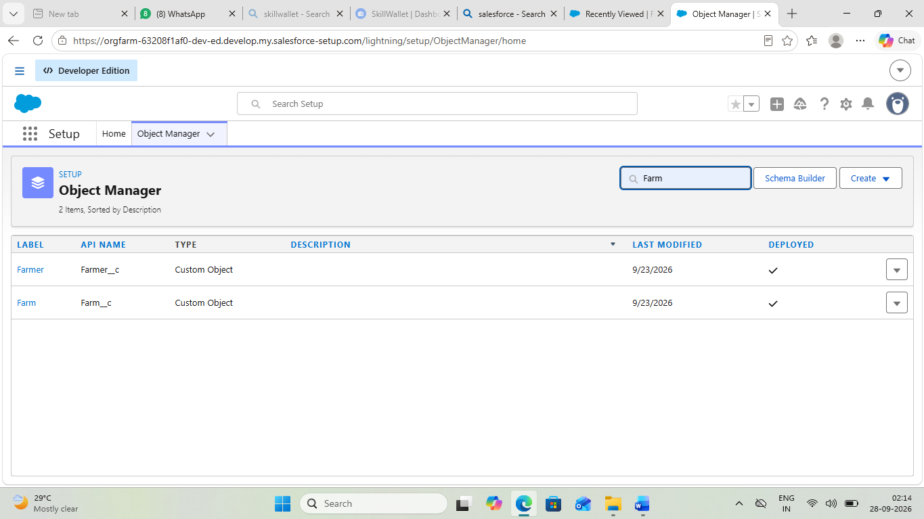
Fig 1: Custom Objects Created

6.3 Tabs & Lightning App
Custom tabs were created for Farm, Crop, Farmer and Buyer. A Lightning App named Farm Management System was configured with these tabs, Reports and Dashboards.

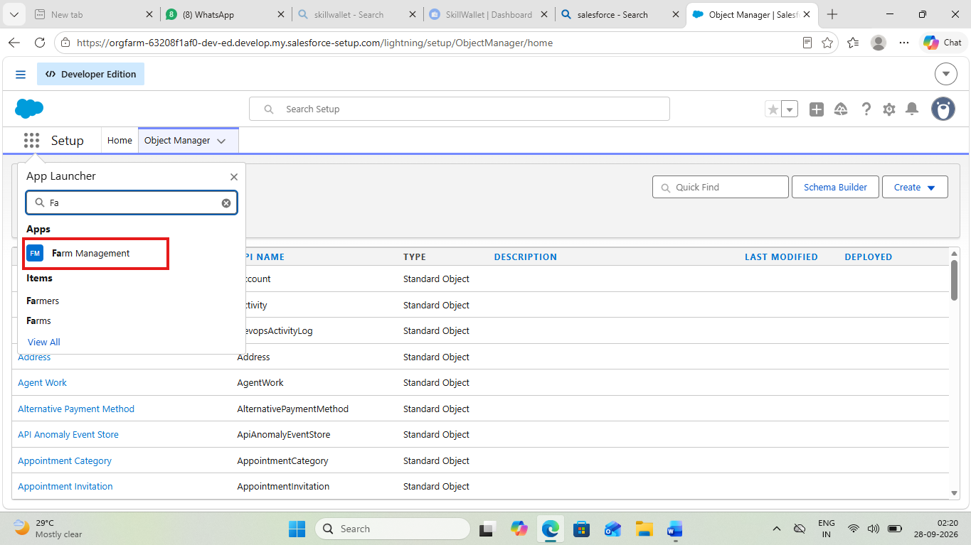
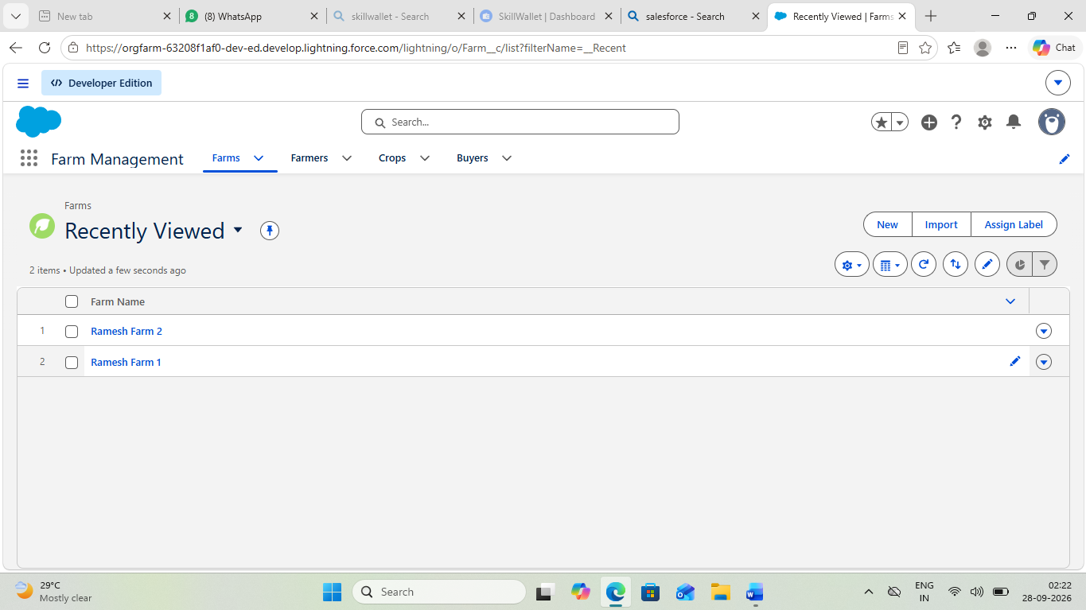
Fig 2 : Lightning App with Tabs
6.4 Fields & Relationships
Picklists, text, phone, email, date, currency, number and formula fields were configured. Farm–Farmer and Crop–Farm relationships were created. A State–District field dependency was also configured.

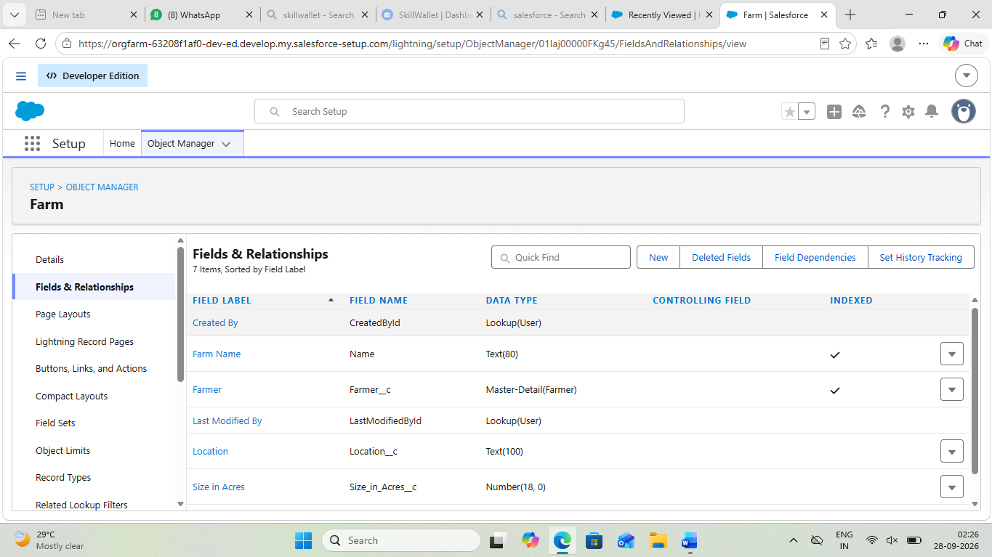
Fig 3 : Fields & Relationships

6.5 Profiles, Roles, Users & Sharing
Custom profiles such as Farm Manager and Sales Department were configured. A Farm Manager role and users were created. Sharing rules were used to provide appropriate Read/Write access.
6.6 Reports
A 'Farmers with Farms' report was created by grouping farm records by Farmer Name. Reports for crops and buyers can also be created for monitoring operations.
Fig 4 : Farmers with Multiple Farms Report – Showing Ramesh with 2 Farms

6.7 Dashboard
A dashboard named 'Farmers with Farms' was created using the report and displayed using a Gauge/Chart component.
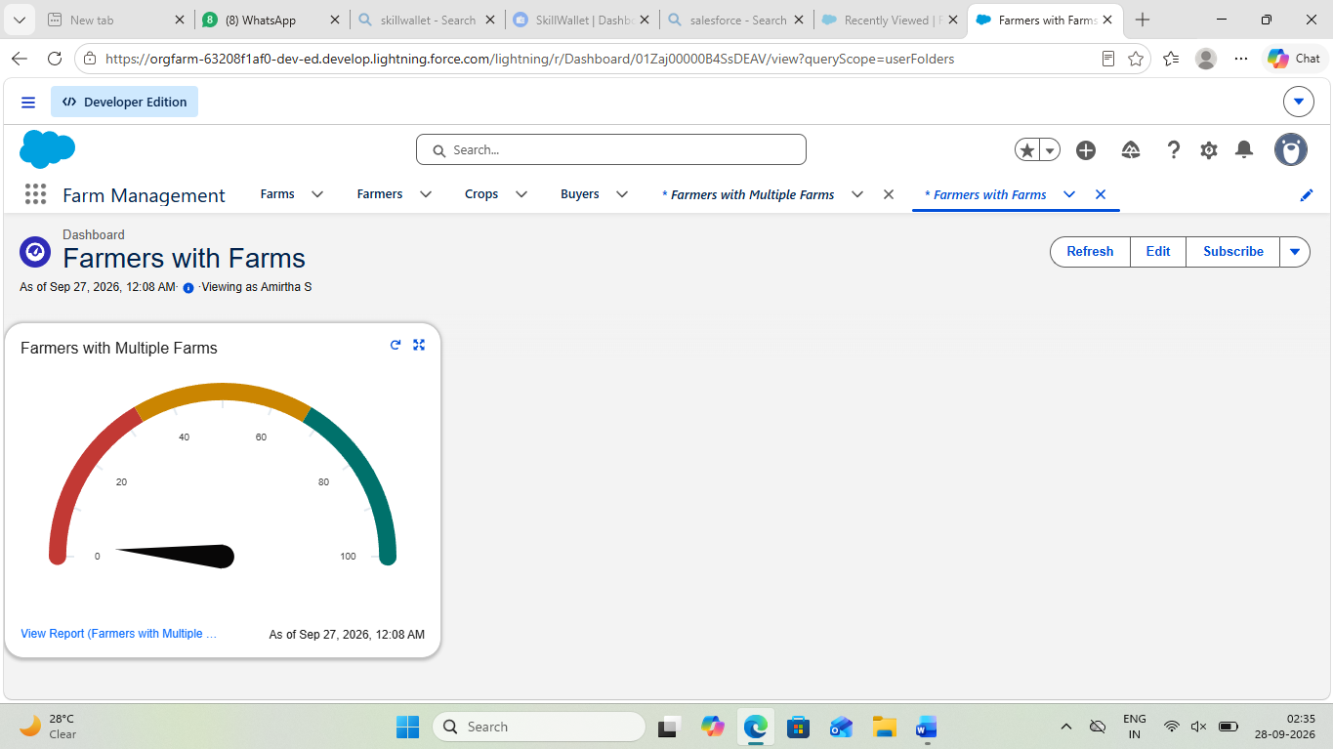
Fig 5 : Farmers with Farms Dashboard

6.8 Demo Steps
- Open App Launcher and search Farm Management System
- Open the required Farm, Crop, Farmer or Buyer tab
- Open Reports and select Farmers with Farms
- Open Dashboards and select Farmers with Farms
- Verify the displayed records and chart

Fig 6 : Application Access

7. Functional & Performance Testing
- Farm, Crop, Farmer and Buyer record creation
- Field validation and dependencies
- Object relationship checks
- Profile, role and sharing access
- Report and dashboard generation
- Basic performance and stability testing
8. Advantages & Disadvantages
Advantages
- Centralized data
- Reduced paperwork
- Improved accuracy
- Real-time analytics
- Better monitoring
Disadvantages
- Requires internet connection
- Salesforce license dependency
- Limited offline access
9. Conclusion
The Farm Management System successfully provides a centralized Salesforce-based solution for managing farmers, farms, crops and buyers. Reports, dashboards, validation and security features improve efficiency, reduce errors and support informed agricultural management.
10. Future Scope
- Mobile application integration
- AI-based crop prediction
- Weather data integration
- IoT sensor connectivity
- Government scheme integration
- Market price forecasting
11. Appendix
Source: Salesforce Configuration and Metadata
Dataset: Farm, Crop, Farmer and Buyer Records
Tools Used: Salesforce Developer Org
Thank You

